**Objective**

Create a program that will allow you to show mastery with procedures, subroutines and parameters

**What Do You Do?**

Create a project called shakespeareanInsults. Add the controls shown below with appropriate naming. The program will randomly generate a Shakespearean insult shown in the label.  This program will require you to use both byVal and byRef parameters

a. In the button click, you will need to generate a random number between 1 & 5 that will be passed to the showInsult() procedure. After the call, the insult should be displayed in the label in the button click.

b. The showInsult() procedure should have two parameters: a value parameter to send the random number and a reference string parameter to set the insult. In the sub procedure, use a decision statement to determine which “insult” is set to the string variable.

c. Insults: "I think he be transformed into a beast; for I can nowhere find him like a man” ~ As You Like It "Lets meet as little as we can" ~ As You Like It "I desire that we be better strangers" ~ As You Like It "Boys, apes, braggarts, jacks, milksops!" ~ Much Ado About Nothing "This is the silliest stuff that I ever heard" ~ A Midsummer Night's Dream

**It should look similar to the example below.**

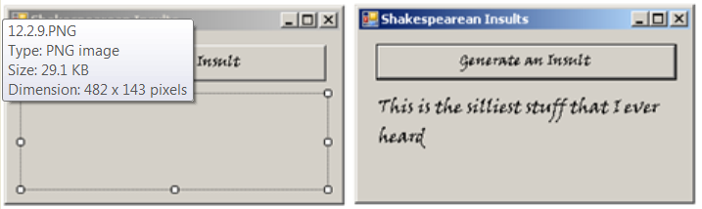

**Submit Your Assignment**

When submitting programs, please remember that in order to have an opportunity to earn full credit, you must complete the following:

* Click “Submit Assignment” in the upper right corner of the screen.
* To upload a file, click on**Choose File** to select the file from your computer.
* Attach the .vb file (the one with your code in it)
* Attach the executable file (.exe)
* Note: BOTH files are needed for full credit.
* Finally, click "Submit Assignment" for it to be graded by the teacher.

Please check out the file and video on How to Correctly Submit a Program in the How do I...? folder for further instructions.

IMPORTANT Full Credit Submission Reminders:

* Remove the control names (ie label, button) from the form
* Add your documentation to your code
* Validate any user input.

**How You Will Be Evaluated**

Instructors will look for a working, well-documented program that meets all the requirements in the instructions.

**To Continue**

After completing and submitting this assignment, click Next below to continue